TimeSheets Threat Model

An image of a spreadsheet with the Udacity logo in it.

Scenario
Your company utilizes a custom application, called TimeSheets, to log timesheets. This custom application was built in-house. Until recently, this application was only accessible via the internal corporate network. Due to an increasingly mobile workforce, the need to access the application externally has started to increase. Business leaders made the suggestion of using the existing application and exposing it externally. Last week, IT made the change to allow users to connect externally.
Shortly after exposing TimeSheets externally, the IT and security operations teams began noticing odd behavior related to TimeSheets. IT has seen a significant amount of users reporting incorrect data in the system. The security operations center has noticed logins from unexpected locations and unexpected times. After raising an incident, it was determined that unauthorized logins were occurring.
After resolving the incident, your team was asked to come in and assess the application and provide recommendations. A senior security engineer from your team completed the initial threat model related to the incident. During the threat model, your colleague discovered the root cause for the incident as well as several other vulnerabilities - all of which are related to encryption. Due to other obligations, your colleague has asked you to complete their work.

Your Project Submission
To successfully complete this Part A of the project, you will need to complete a Threat Review document which will require the following:
- Threat Model Review and complete a Threat Assessment.
- Analysis of Vulnerabilities
- Risk Analysis
- Mitigation Plan
Your final report should be a .pdf document with the name, TimeSheets Threat Report.pdf.

Part A.1: Threat Assessment
Lesson

Section 1: Initial Threat Assessment
You have been given an incomplete threat model.
- Powerpoint Version of TimeSheets Threat Report(opens in a new tab)
- Google Slides Version of TimeSheets Threat Report(opens in a new tab)
The threat model lists a number of issues that have been discovered. Your first job is to analyze the partially completed threat report.
Your coworker completed several sections:
- An Asset Inventory
- An Initial Threat Model
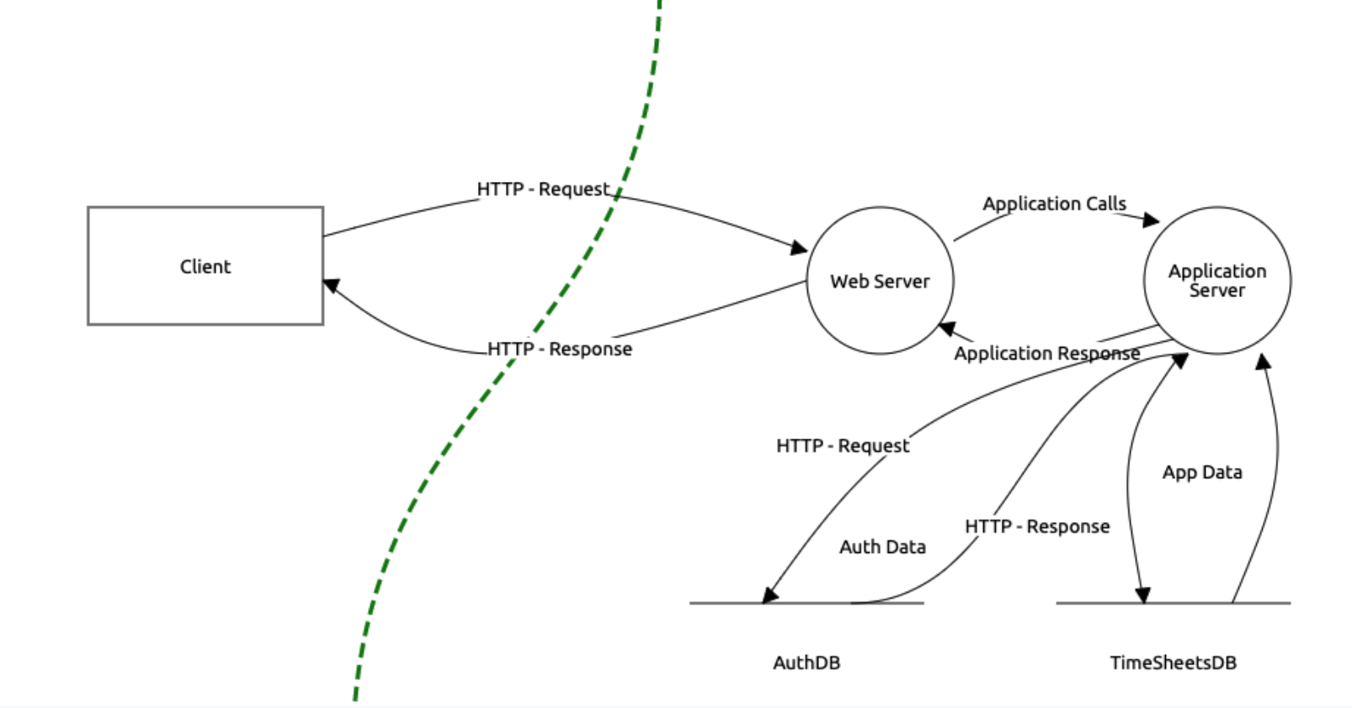
TimeSheets Threat Model
- A Threat Analysis
- A Threat Actor Analysis
Download the threat report and look over your coworker's observations. You will use this information in the next sections and fill in your answers and observations in the Threat Report document.

Part A.2: Vulnerability Analysis
Lesson

Section 2: Vulnerability Analysis
Your coworker has listed each of the discovered vulnerabilities.
- Employee Data Unencrypted at Rest
- Authentication Data Stored Using Reversible Encryption
- Authentication Requests are Unencrypted in Transit
- DES Algorithm in Use
You need to explain why these are considered vulnerabilities. Make sure to include the potential consequences of a successful exploit.

Part A.3: Risk Analysis
Lesson

Section 3: Risk Analysis
Rank each of the four identified encryption issues in order of severity (1 being the most severe, and 4 being the least severe). Explain your reasoning for the ranking. It may help to use a tool or specific methodology, but you must go a step further than just ranking based on the scoring and provide further reasoning. You must provide justification for each ranking (i.e. why is this the highest/lowest relative to the others).

Part A.4: Mitigation Plan
Lesson

Section 4: Mitigation Plan
Suggest remediations for each of the vulnerabilities. Additionally, you must justify your mitigation plan. It is not sufficient to just specify a fix, you must explain why your recommended course of action will work.
To finish out the section, come up with recommendations for the audit team (i.e. what steps can the audit team take to ensure this issue doesn’t recur). Hint: Does a policy exist? If not, how would you solve this? This will help ensure you solve the issues going forward.

Project B Overview
Lesson

Password Vault with Master Key Security
Scenario
You are to develop a "Password Vault with Master Key Security" to securely store and retrieve passwords. We all now have hundreds of online accounts for which we have to create strong passwords that should also not be repeated across domains. And since it is difficult to remember all these passwords, this secure password repository should help. It requires the creation of a simple application that encrypts and stores domain/website passwords with unique keys and employs a hashed master key for secure access. The solution should include two main functionalities:
- Adding every new password to the repository with encryption
- Retrieval process of the passwords that necessitates master key verification.
You can use Python to develop the application. This project allows you to apply what you’ve learned in the course. For successful completion of the project, you will be doing: 1. Master key creation and storing it 2. Securely store passwords 3. Retrieve passwords using master key access 4. Automate tasks using shell scripting
Use the project specifications in the below pages and the rubric as guides to develop and submit the required parts of the project. It is required to submit source code file for each of the parts of the project. Name each file with its corresponding part number grouped in a single folder.

Part B.1: Master Key Creation and Hashing
Lesson
On first use, the user is prompted to create a master key. This key serves as the primary authentication method for accessing the password manager.The master key is then hashed using a hashing algorithm. This hashed master key is stored securely, separate from the password database. (Salting the hash can be considered a add-on).
Use the workspace at the bottom of this page to implement your program.

1 User Interface for Master Key Creation
Code a prompt for the user to create a master key on first use.

2 Implement Hashing Function
Hash the master key using a secure algorithm, optionally adding salt.
Use the SHA-256 algorithm for hashing

3 Secure Storage of Hashed Master Key
Store the hashed key securely, separate from the main password database.
Use the below workspace for writing and running your Python code.

Part B.2: Storing Passwords
Lesson
- User Input: The user enters a domain, username, and password, which he/she has probably created for a website and wants to store it so that it's not forgotten. This input can be done via a simple program using Python.
- Password Encryption: The entered password is encrypted using a new, unique encryption key. Inbuilt cryptographic libraries can be used to generate the key and perform the encryption.
- Password Hashing: Alongside encryption, a hash of the password is also generated using a secure hashing algorithm. This hash serves purposes such as integrity checks and duplicate password detection.
- Storage: The domain, username, encryption key, encrypted password, and password hash are stored in a file, called a password file. Each entry is delimited by a colon (:) and stored on a new line for easy retrieval. Example entry:
Domainname:username:encryption key:encrypted password:password hash
https://www.google.com/:username:D0uumUNaESsRM7uU7gYa0cG1o8u4YGnAyc5diIpTmOk=':gAAAAABl4DkBEw2AYRl5wDXeHEhbcjU6FkkKAuAKqG7NBU4resLxLQMBdaOQOJtUbPaaoeThq6eMFiehAcYcD740BnhR0lhFg==:a8cfcd74832004951b4408cdb0a5dbcd8c7e52d43f7fe244bf720582e05241da(opens in a new tab)
Use the workspace at the bottom of the page to do your coding.

1 Take User Input
Implement python code to receive input - domain,username, and password.

2 Password Encryption
Encrypt passwords using a unique key for each entry.

3 Password Hashing and Storage
Hash the encrypted password and store all details securely in a password file.

Part B.3: Retrieving Passwords
Lesson
- Master Key Verification: Now when a user wants to retrieve a password, a part of the program should ask for a master key. Upon entry of the master key, the program should hash the entered key and compare it with the stored master key hash.
- Search and Decrypt: If the master key verification is successful, the program should search the password file for the specified domain. It uses the stored encryption key to decrypt the corresponding password.
- Password Retrieval: The decrypted password should then be presented to the user. Additional security measures, such as a timeout or a limited number of access attempts, can be implemented to enhance security further.
Use the workspace at the bottom of the page to do your coding.

1 Implement a function
Prompt the user for the master key upon request to retrieve a password.
Hash the input and compare it with the stored master key hash for authentication.

2 Upon successful authentication
Search the password file for the requested domain.
Decrypt the password using the stored encryption key.

3 Display the decrypted password to the user
Implement security measures such as limiting the number of access attempts or ad

Part B.4: Shell scripting
Lesson
- Write a shell script that prompts the user for a domain name and then executes a Python script to retrieve a password for that domain.
- Write a shell script that authenticates the master key by calling the Python script written in the first part of the project, that performs the actual authentication process.
Use the workspace at the bottom of the page to do your coding.
- For an enhanced user experience
Write shell scripts that allow users to interact with your password manager through simple commands.
Include scripts for adding a new password and retrieving an existing password.
- Ensure your shell scripts handle errors gracefully and secure the master key during authentication

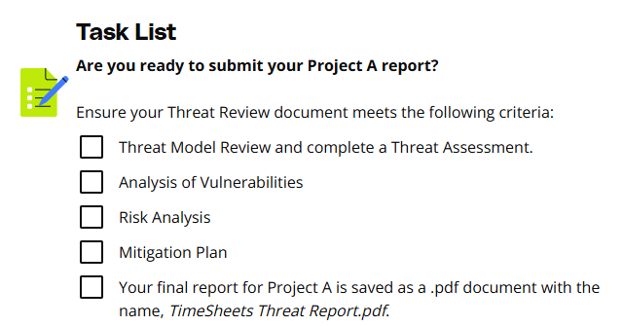
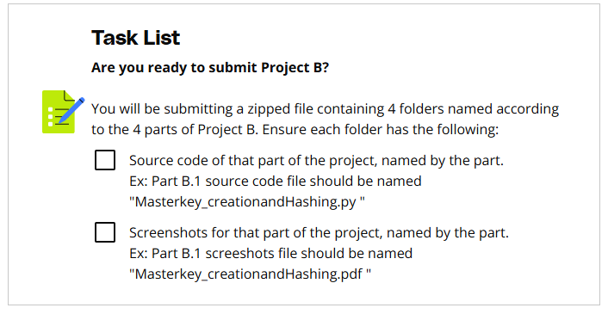

Rubric
Use this project rubric to understand and assess the project criteria.

Vulnerability Analysis
Criteria | Submission Requirements
Demonstrate understanding of encryption issues | Explain why the four identified encryption issues are considered vulnerabilities and the potential result of each exploited vulnerability. For each vulnerability, detail why it is considered a vulnerability and discuss the consequences of exploitation.

Risk Analysis
Criteria | Submission Requirements
Assess risks and prioritize what should be fixed first | You must rank each of the four identified encryption issues and explain your ranking. Your explanations must be based on content from this course as well as observations from the initial report.

Mitigation Plan
Criteria | Submission Requirements
Recommend mitigation plans for each vulnerability to engineering teams | You must create a mitigation plan with justification for your recommendations in 4 to 6 lines.  The audience is engineering teams who may or may not have an understanding of why these are issues. Additionally, they may need assistance in implementing your recommendations. You must provide guidance on how to implement your recommendations. Provide clear, actionable steps (3 to 6 steps) for engineering teams to implement the mitigation strategy.
Recommend a basic audit strategy to assist the audit team with ensuring compliance of recommended encryption activities | You must suggest steps that the audit team can take to ensure that the systemic encryption issues are solved going forward.

Master Key Creation and Hashing
Criteria | Submission Requirements
Demonstrate knowledge of using hashing for master key creation. | Include a code snippet showing the use of built-in hash functions implementation and a screenshot of the terminal or console output displaying the prompt for creating the master key without revealing the actual key or its hash.

Storing Passwords
Criteria | Submission Requirements
Use symmetric encryption and hashing algorithms to create a password file. | Provide a source code of the encryption and hashing logic and a sample encrypted entry in the password file. Screenshots of the program accepting user input and storing the data securely can also be included.

Retrieving Passwords
Criteria | Submission Requirements
Demonstrates required hash comparison for verifying Master key and is able to decrypt data. | Submit a code snippet for the master key verification and password decryption process, along with a screenshot showing the retrieval of a password.

Shell scripting
Criteria | Submission Requirements
Write shell scripts to automate tasks like call and executing python scripts. | Include the shell script code and screenshots of the script execution, demonstrating the user input prompt and the successful call to the Python program.

Suggestions to Make Your Project Stand Out
- Using the information provided, you can infer that there are other problems. Create a plan for solving more than just the identified issues.
- Provide as much detail as possible. There will be times when you have to make the audience understand why your findings are considered vulnerabilities.
- Leverage industry standards as much as possible. In absence of that, provide solid justification when explaining issues and remediation plan.
- If possible, provide a proposed architecture diagram of a secure system

Project: TimeSheets Threat Model
Past Due on January 5, 2026

Project Submission
Please zip together the following in a single submission file:
- TimeSheets Threat Report.pdf of Project A
- Zip file of Project B

Double-Check the Rubric
Before submitting your project, please review the project rubric to confirm that your project meets all of the required specifications. Your project will not pass unless all of the requirements are met.

Project Submission Checklist
Before submitting your project, please review and confirm the following items.
- I am confident all rubric items have been met and my project will pass as submitted. (If not, I will discuss with my mentor prior to submitting.)
- Project builds correctly without errors and runs.
- All required functionality exists and my project behaves as expected per the project's specifications.
Once you have checked all these items, you are ready to submit!

